Andrew Cope Visits Shelton Junior School

**Written by: Jessica Taylor-Lengyel (10) and Ryan Chu (10)**

Thursday 12th September 2024

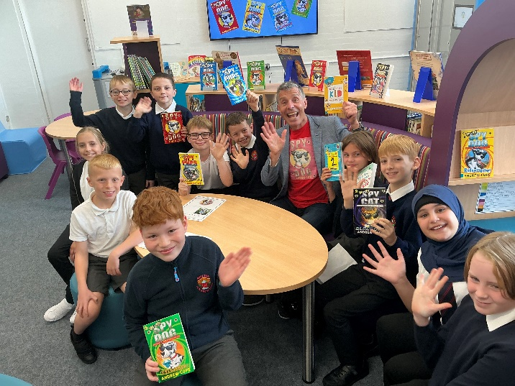 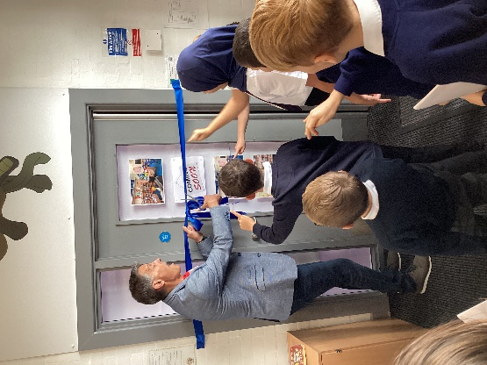

Today, Andrew Cope, a well-known local children’s author, opened a brand new and exciting library at Shelton Junior School. Andrew Cope has written a series of exciting Spy Dog books along with Spy Cats and even 2 books about racoons! The children at Shelton Juniors love these books and were happy to welcome the famous author to their school.

Along with a number of excited children, Andrew cut the ribbon and encouraged everyone to explore a fully refurbished, colourful and relaxing new library. He then signed books and answered questions posed by the children. They found out more about Andrew’s lifestyle, writing and his famous dog, Lara.

Following the launch, the children are now looking forward to enjoying this lovely new space. They can’t wait to read new books (some of which were signed personally by Andrew Cope) and discover new things.

Why not come and see our brand new library for yourself?!

