This is the phase transfer review of my education, health, and social care (EHC) plan.

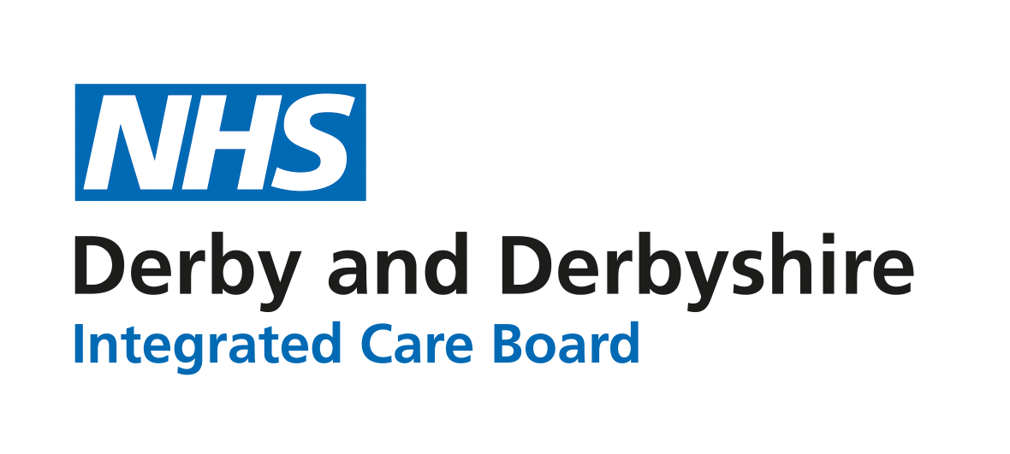

About this review
Child / young person name
Address at time of review
Age at review
Current school or educational setting
Year group
Date pre-panel paperwork sent out
Date of review meeting
How was the review held? | Meeting at the educational setting, Meeting held elsewhere,  Video call (Teams/Zoom), Telephone
Provide details of the contributors to the annual review meeting (add more rows as required):
Name | Role or relationship to child/young person | Attended | Apologies received? | Report received?

Review of views, interests, and aspirations
My story

Things I’m good at:

Things I like, things I don’t like and things I would like to try:

Things that other people like about me:

Things I like about myself:

What’s working well, what’s not working so well and what I would like to change:

My hopes and dreams for the future:

How I want my voice to be heard:

How were these views captured?
Directly from the young person, Through a parent or carer, Through an advocate/professional, Other

My family story, including our views, interests and aspirations

The important people in my life (family, friends, favourite people, even pets)

(B) Review of strengths and special educational needs
Is there a significant change to the needs of the child or young person since the plan was last issued? |  | Yes, No,

Identify any changes to the special educational needs of the child or young person. Clearly identify the information in the current plan that needs to be removed or amended. Clearly state any new strengths or needs that need to be added to the plan. If the strengths or needs remain the same, please state ‘NO CHANGE’ in the relevant section.
Communication and interaction | Strengths:  Special Educational Needs:
Cognition and learning | Strengths:  Special Educational Needs:

Details of current academic levels should be provided (Please identify which assessment tool has been used. Where possible these should be provided in the context of age expected levels):
Subject | Assessment of current level

Reading

Writing

Maths

Other subjects (list any particular areas of strength or challenge)

Social, emotional and mental health | Strengths:  Special Educational Needs:
Sensory and/or physical | Strengths:  Special Educational Needs:
Independence | Strengths:  Special Educational Needs:
What does the Derby Inclusion Tool indicate about the strengths and needs of the young person? (Include a completed eDIT with this form)
(C) Review of health needs
Is there a significant change to the health needs of the child or young person since the plan was last issued? | Yes, No,
Clearly identify the information in the current plan that needs to be removed or amended. State any new strengths or needs that should be added to the plan. If the strengths or needs remain the same, please state ‘NO CHANGE’ in the relevant section.
Health needs that have been identified in the EHC assessment (in priority order, where possible)
Details of any current health care plans in place and/or diagnoses given that might impact on progress

(D) Review of social care needs
Is there a significant change to the social care needs of the child or young person since the plan was last issued? | Yes, No,
Clearly identify the information in the current plan that needs to be removed or amended. State any new strengths or needs that should be added to the plan. If the strengths or needs remain the same, please state ‘NO CHANGE’ in the relevant section.
Social care needs that have been identified in the EHC assessment (in priority order, where possible)
Details of any current social care plans or orders in place

(E) Review of outcomes and provision
Summary of current outcomes. Provide details of the progress made against these outcomes
 | Outcome (copy from plan) | Status of outcome
Not yet met.
Partially met – progress made.
Achieved.
No longer relevant.
Not yet met.
Partially met – progress made.
Achieved.
No longer relevant.
Not yet met.
Partially met – progress made.
Achieved.
No longer relevant.
Not yet met.
Partially met – progress made.
Achieved.
No longer relevant.
Not yet met.
Partially met – progress made.
Achieved.
No longer relevant.

Provide an update to the existing outcomes. If the existing outcomes do not need changing please mark the relevant box with ‘NO CHANGE’. Where a change to the current plan is needed please clearly identify which information needs adding, changing, or removing.

Review of outcome and provision E1

Outcome to be achieved by the end of the current Key Stage/phase
New targets for the next 12 months
(F) Special Educational Provision | Amendments to the provision set out in the plan | Who by

Review of outcome and provision E2

Outcome to be achieved by the end of the current Key Stage/phase
New targets for the next 12 months
(F) Special Educational Provision | Amendments to the provision set out in the plan | Who by

Review of outcome and provision E3

(E3) Outcome to be achieved by the end of the current Key Stage/phase
New targets for the next 12 months
(F) Special Educational Provision | Amendments to the provision set out in the plan | Who by

Review of outcome and provision E4

(E4) Outcome to be achieved by the end of the current Key Stage/phase
New targets for the next 12 months
(F) Special Educational Provision | Amendments to the provision set out in the plan | Who by

Review of outcome and provision E5

(E5) Outcome to be achieved by the end of the current Key Stage/phase
New targets for the next 12 months
(F) Special Educational Provision | Amendments to the provision set out in the plan | Who by

New outcome and provision
Provide a summary of any proposed new outcomes agreed at the review. Add more rows if required. Clearly state ‘NONE’ if no new outcomes should be added to the plan:

Outcome to be achieved by the end of the current Key Stage/phase
Over the next 12 months
(F) Special Educational Provision |  | Who by
(I) Placement details
Provide details of the parental or young person preference for placement in the next phase of education.
Type of provision preferred | Mainstream school or post-16 provider, Enhanced resource provision,  Derby special school, Other (please state)
Preferred setting
Additional comments about the preferred setting for the next phase of the young person’s education
(J) Personal budget – Including arrangements for direct payments
Is a personal budget in place? | Yes, No,
Provide details of any changes needed to the personal budget:

Key findings of the review
Is an EHCP still needed? | Yes, No,
Does the existing EHCP need to be updated following this review? | Yes, No,
Provide a summary of the discussion and the key findings from the review. This should capture any agreed actions from the review, and highlight anything that may prevent outcomes from being met:

Signatures
School representative name
Role
Name
Parent/carer/young person

Please send this completed form along with any accompanying reports to EHCP.Review@derby.gov.uk, within 2 weeks of the date of the meeting
What to include with your annual review paperwork:
- A completed Derby Inclusion Tool
- Child/young person views
- Family views
- Any professional advice gathered from those working with the young person

