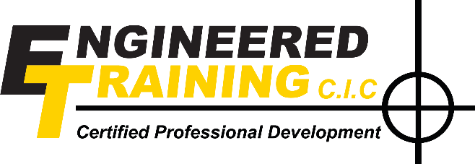
Bike Maintenance Summer Programme 2020
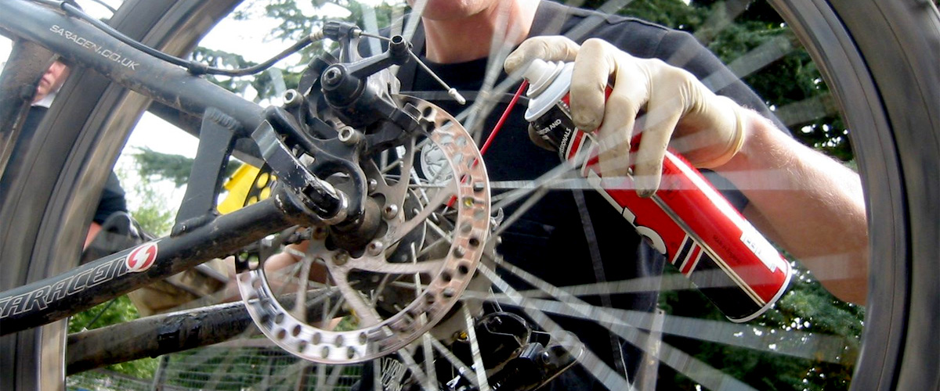
Bike Maintenance Sessions are they for me?
- Do you like Bikes?
- Do you like working on Bikes?
- Do you want to learn how to Fix Bikes?
- Do you want better Job Prospects?
If you’ve answered yes to any of the above questions then our Summer Bike Maintenance Sessions are just what you’re looking for.
Run by a friendly team of experienced bike enthusiasts, technicians and mechanically minded folk, we will teach you Service, Repair, Refurbish, Spray and Customise bikes.
So why not join us and learn new skills, improve your job prospects and have fun!
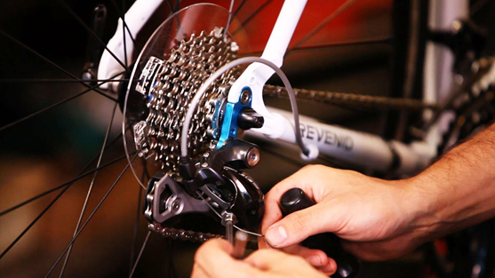
Bike Maintenance Summer Programme 2020

Here’s the answer to some questions you may have:
Do I have to pay? No - we have been lucky enough to receive some funding so you don’t have to.
Do I need to know anything about bikes? No- but be prepared to learn.
Will I need to bring a bike? No - we have bikes is various states of repair ready for you to work on. There’s even a chance that you might be able to take one home.
Can I work on my own bike? Yes – Feel free to bring yours along.
When are the sessions? We’ll be running on Tuesday’s and Thursday’s throughout the Summer Holidays from 10:00am to 2:00pm.
When’s the first session? We start Tuesday 30th July at 10:00am
Where is it? We are based at Engineered Racing Ltd, Unit 8 Racecourse Industrial Estate, Mansfield Road, Derby, DE21 4SX (Opposite Rollerworld) in Derby, just outside of the City Centre.
What will I be doing? The sessions are very hands on - we will be teaching you practical bike maintenance skills from day one.
Do I need any special equipment? No, we will provide all the PPE (personal protective equipment) and tools you need.
What should I wear? Old clothes and sensible shoes—we will provide protective footwear
Is lunch included? Yes it is.
Is there a lot of theory/written work? No, it’s really hands on.
OK I want to do the course—what do I do next? Just complete the form with this leaflet (or get your legal guardian to do it if you are under 18)
Once complete either drop it through our letterbox or send it to us at
Engineered Training CIC, c/o Engineered Racing Ltd, Unit 8 Racecourse Industrial Estate, Mansfield Road, Derby, DE21 4SX
or email it to adrian@engineeredlearning.co.uk

Bike Maintenance Summer Programme 2020
Application Form

CONFIDENTIAL
All information contained in this document will be treated as confidential.
This form must be completed by the parent/guardian of any person under the age of 18 (or by the participant if over 18) before they may participate in any learning organised by Engineered Training CIC.
PERSONAL DETAILS
Participant’s Full Name:
Home Address:
Date of Birth: | DD | MM | YY
Age:
Gender: | ¨ Male | ¨ Female
I agree to my son/daughter* having the opportunity to participate in metal fabrication and welding.
* delete as applicable
I understand that although potentially hazardous, an instructor who holds the relevant awards / experience / qualifications will lead these learning activities and will maintain a high level of safety throughout the activities.
I acknowledge the need for responsible behavior and that the instructors’ word is final on all matters of safety.
HEALTH
Does your son/daughter have any food allergies or dietary requirements? |  |  |  | Yes |  | No
If Yes, please give details:

Are there any medical conditions or disabilities which we should be aware of? |  |  |  | Yes |  | No
If Yes, please give details:

MEDICAL
Do you consent to your son/daughter receiving emergency medical treatment in an emergency? |  |  |  |  | c Yes |  | c No
Do you consent to your son/daughter receiving first aid treatment including the application of plasters? |  |  |  |  | c Yes |  | c No
Doctor’s Name:
Doctor’s Address:
Doctor’s Telephone Number:
EMERGENCY CONTACT DETAILS for the duration of the course
Contact Name:
Contact Address:
(if different from home address)
Contact Telephone Number: |  |  |  |  |  | Home
 |  |  |  |  |  | Mobile
INSURANCE
I understand that Engineered Training CIC is covered in the event of an accident caused by their negligence but personal insurance for participants is not provided.
Signed: |  |  |  | Date:
Engineered Training CIC’s Safety Policy is available from your organizer.

