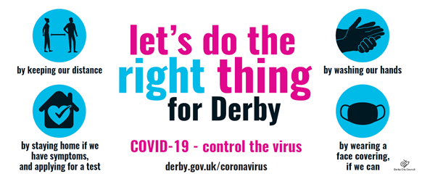

COVID-19 Protocol for schools and early years providers in Derby
Contents
Updates: 1
Background information: 1
Case definition: 1
Contact definitions: 1
Infectious Period: 2
Prevention 2
Testing 2
Flowchart for response to possible or confirmed cases in your setting 3
Investigation template 4

Updates:
- Improved testing capacity
- Flowchart: who to contact and when

Background information:
This document outlines the actions required to manage suspected or confirmed cases and reduce onward transmission of COVID-19 in educational and early years settings in Derby.
It is expected that settings will be familiar with the government guidance (updated 26th November 2020) at https://www.gov.uk/government/publications/actions-for-schools-during-the-coronavirus-outbreak/guidance-for-full-opening-schools and have undertaken risk assessment and implemented mitigating actions.

Case definition:
Confirmed case: laboratory positive case of COVID-19 with or without symptoms
Possible (suspected) case: new continuous cough and/or high temperature and/or anosmia

Contact definitions:
Household Contacts: Those that are living or spending significant time in the same household e.g. those that live and sleep in the same home, people who live in the accommodation that share a kitchen and bathroom, and people who have cleaned a household where a case lives without personal protective equipment.
Direct close contacts: face to face contact with an infected individual for any length of time, within 1 metre, including being coughed on, a face to face conversation, or unprotected physical contact (skin-to-skin)
Proximity contacts: Extended close contact (within 1-2metres for more than 15 minutes) with a case, including travelling in a small vehicle with a case

Infectious Period:
The infectious period is from 48 hours prior to symptom onset to 10 days after, or 48hrs prior to test if asymptomatic
The charts overleaf advise what to do if you have a possible case, or 1 or more confirmed cases in your setting. This applies to teaching staff, support staff and students

Prevention
The main tools to limit transmission of the virus are social distancing, hand washing and use of face coverings. These are important for pupil, staff, visitors and parents when they come to school. If you would like promotional material to support this please contact Laura.Bandell@Derby.gov.uk

Testing
Testing capacity has improved in the city with multiple walk through sites, in addition to the drive through site at Toyota. Anyone who needs a test should be able to get one promptly and close to home. Please be advised that, unless otherwise advised, tests are only for those with symptoms to help manage their infection, contact tracing and management of settings. Please book tests by calling 119 or accessing https://www.gov.uk/guidance/coronavirus-covid-19-getting-tested

Flowchart for response to possible or confirmed cases in your setting
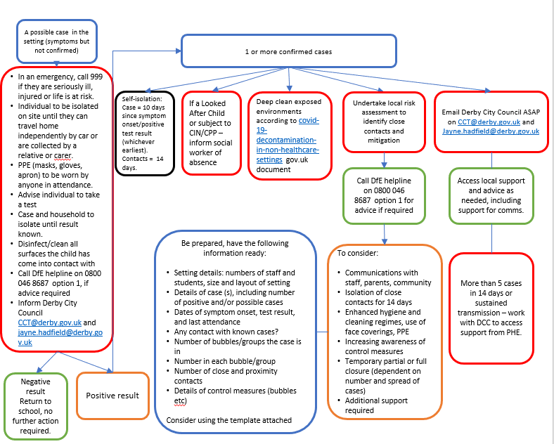

Derby City Council COVID CCT Notification Form
Email to CCT - CCT@derby.gov.uk
Date
Contact Details
School Name
School Address
School contacts name
Telephone number
(if school is closed please also include a mobile)
Details of positive case
Staff | Yes/ No
First name
Details of role in school inc. year group
Questionnaire provided to complete.
Pupil | Yes/ no
First name
Year group and class
Findings of investigations/ identification of close contacts
Details of any links with other positive cases ( family / friends/ close contacts out of school)
Details of any links with other positive cases within the school setting?
Action
Actions taken
( ie, closure of classes/ year groups)
Have you sought advice from PHE/ DoE?
Do you need us to contact you to provide further advice?

