Laddering Activity

Developing an anxiety or exposure ladder with the pupil can be helpful. The individual would be asked to identify the situation in school which they are most worried about and then less fearful situations, working down the ladder. On the bottom rung of the ladder would be the situation that the pupil feels least fearful or worried about. This would be a useful starting point for any subsequent plan with each step being consolidated before moving on. A blank ladder template and examples have been included below. Each ladder will, of course, reflect the thoughts and feelings of the individual pupil.
Laddering activity: this activity requires pupils to think about different situations related to attending school that they are most or least worried about. Provide the pupil with a range of activity statements/situations which reflect their current school experience and daily life. Statements should be tailored to each pupil. Include some ‘blank’ cards to add further situations should they come up in conversation with the pupil.
Ask the pupil to sort the situations according to those they feel ‘most worried about’, or most bothered about (common responses are ‘leaving the house’ or ‘going into a named lesson’), and those they feel least/not so worried about or are not really a bother for them. Ask the pupil to order the statements from the top to the bottom of the ladder (from most worried about to least worried about). The laddering activity is a useful starting point for planning support and in identifying small step goals we might first need to address to help the pupil to manage their feelings/specific situations, and to build up their school attendance.
Addressing situations the pupil is least worried about should be worked on first. Each step on the plan should be consolidated before moving onto the next. (See example laddering activity). Each ladder should be personalised to the pupil, including use of pictures or modified with symbols as appropriate to the pupil’s needs.
Adapted from Lancashire County Council ESBA guidance, with thanks to Derbyshire EPS team.

Ladder Template

Most worried about

Least worried about

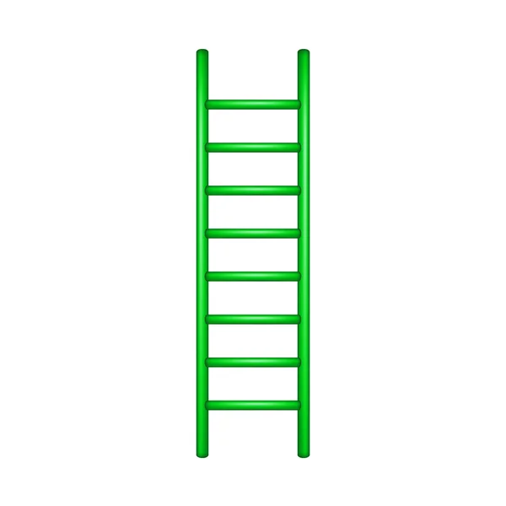

Laddering Activity (Example Statements)
Going into a busy dining hall at lunch time | Putting on my uniform at home in the morning
Going into an empty dining hall | Lunch time
Speaking to another pupil you know | Break time
Speak to another pupil you do not know | Eating in school
Going into a lesson you enjoy | Going to the toilet in school
Going into a lesson you do not enjoy | Travelling to school
Seeing pupils around school | Leaving the house
Going into a classroom full of students | Teachers asking me a question
Going into an empty classroom | Making a mistake
Going into the reception area/walking into the school building | Understanding what I need to do
Getting a question wrong in my book | School rules, such as…
Getting a question wrong in the lesson | Seeing my friends in school
Understanding what the teacher means | Other pupils asking me questions
The smell of… | The noise of/in…
Writing my work | Walking around the corridors
PE lessons | Meeting a member of staff in the school car park

