Derby City Council – First-aid Policy and guidance document

Version control | Final
Author | Darren Allsobrook
Key stakeholders / contributors | Corporate Health and Safety Team, Corporate Policy Group, HR & OD, Trade Unions – Health and Safety Development Group
Lead Directorate | Corporate Resources
Implementation date
Review date (every three years or sooner if changes require)
Approving body | Corporate Health and Safety Committee
Approval date | 28th April 2022
Accountable Service Director | Steve Caplan – Director of Property Services

Introduction
The Health and Safety (First-Aid) Regulations 1981 require that all workplaces have suitable and sufficient cover for providing First-aid to people who are injured or who become ill at work. Although the regulations outline the essential aspects of first-aid that must be provided, no fixed levels of equipment or personnel are stated. The level of first-aid cover needed should be determined by carrying out an assessment of the risks present within individual workplaces.

Purpose
This policy sets the requirements for providing adequate first-aid provision at work in the Council. The purpose is to provide suitably trained and equipped personnel to treat colleagues and others using our sites if they become ill or injured.

Scope
The Council undertakes numerous activities that present significantly different risks and therefore require varying levels of first-aid. This policy recognises this variation and provides the method for determining the level of appropriate first-aid provision required in relation to people and equipment by the completion of a first-aid needs assessment for each workplace.
Sections
- Section 1: First-aid needs assessment
- Section 2: First-aid materials, equipment and facilities
- Section 3: First-aid personnel
- Section 4: First-aid training
There are six appendices which mirror the four sections of this procedure with a final checklist to assist managers.

Terminology
First-Aid”
(a) in cases where a person will need help from a medical practitioner or nurse, treatment for the purpose of preserving life and minimising the consequences of injury and illness until such help is obtained,
and (b) treatment of minor injuries which would otherwise receive no treatment, or which do not need treatment by a medical practitioner or nurse
First-Aider”
(a) Someone who holds a valid certificate of competence in either; first-aid at work (FAW) or emergency first-aid at work (EFAW). The content of FAW and EFAW courses are listed in Appendix 4.
(b) Colleagues undertaking the role of the First-aider must be in a position to leave their own work immediately to attend to a situation where first-aid is required. If someone is in a role which does not allow immediate exit they should not be considered as a first-aider

Appointed Person”
When the assessment of first-aid needs identifies that a first-aider is not necessary, the minimum requirement is to nominate an Appointed Person who will be responsible to take charge of the first-aid arrangements, including looking after any first-aid equipment and re-stocking the first-aid box, and calling the emergency services when required. Arrangements should be made for an Appointed Person to be available to undertake first-aid duties at all times when people are at work. Appointed Persons are suitable for premises with low risk and few colleagues.

Mental Health First-aid
Mental Health First Aid Training is also available.
MHFA is designed to help people experiencing a change in their mental health. Like traditional first aid, it doesn’t diagnose a problem but provides support, assistance and signposting that people may need. If you want to find out more or become a Mental Health Champion please visit the MiWellbeing pages on MiDerby Health and wellbeing (derby.gov.uk)for more information.

Duties and Responsibilities

Chief Executive
Is responsible for ensuring:
- First-aid arrangements are managed appropriately in accordance with policies and statutory requirements.
- The implementation of a safety conscious culture within the organisation.
Strategic Directors, Service Directors and Heads of Service
Will be responsible for making sure that:
- appropriate first-aid arrangements implemented and maintained within their area of responsibility and that their managers have access to support and advice as required
- adequate resources and access to training are made available to fulfil the requirements of this policy.
Managers must make sure that:
- a suitable and sufficient first-aid needs assessment is carried out for their area(s) of responsibility to determine the level of first-aid provision required.
- appropriate funding is available to train relevant colleagues and provide first-aid equipment. Using appendices 1 – 5 detailed in this policy will help when assessing first-aid needs
- First-Aid at Work Certificates are up-to-date for all first-aiders and providing up-to-date training as necessary
- arrangements are made for first-aid skills to be practised and maintained throughout the period of certification – i.e. refresher training, on-going training.
- the required number of “First-Aiders” or “Appointed Persons”, as determined by the first-aid needs assessment, are identified to other colleagues and are trained. Consideration will also need to be given for cover during shifts, annual leave, sickness and so on .
- first-aid containers/boxes are provided and maintained, the contents are regularly checked and replenished where necessary by the first-aider(s) or appointed person. There is no mandatory list of items to be included in first-aid containers but guidance on the minimum stock of first-aid. See Guidance - Section 2 and appendix 2 for suggested list of contents
- all colleagues, including the induction of new starters, will be informed of this policy and the arrangements made relating to first-aid provision, including the location of first-aid containers and details of first-aiders or appointed person. This should be posted on relevant notice boards
- where more than one Directorate has colleagues located in a workplace or where buildings are occupied with others who are not council employees, appointed persons can be shared across organisations/Directorates, as long as it is clear to all who to contact in the event of an emergency or injury
- first-aid incidents are reported and managed in accordance with the Council’s Incident Reporting Policy and a record kept of any first-aid administered. Where injuries result from work-related activities an accident report form (DCC F2508) must be completed
- a regular review of the first-aid needs assessment is carried out to make sure suitable and sufficient first-aid arrangements are met. It is recommended that this is done at least once a year as part of the general risk assessment process, or more often should circumstances require this.
First-aiders are responsible for making sure that:
- their First-aid at Work Certificate is kept up-to-date by undertaking the relevant training, and at the required intervals
- they attend situations where first-aid may be required, make the area safe and take action without putting themselves or others in danger
- they wear appropriate PPE for the particular scenario – such as disposable gloves and so on
- first-aiders should call for assistance, where this is required, without delay or instruct a named individual to do so, if they are providing first-aid in the interim. They should administer first-aid in accordance with their training and capabilities, until medical assistance arrives if necessary
- they dispose of used first-aid materials and make arrangements for the area to be cleaned as required
- items used from the first-aid box are replaced by the first-aider as soon as possible
- they regularly check first-aid containers to make sure they are kept stocked, and stocks are within use-by date
- first-aid information is up-to-date and in view of employees

Appointed Persons
- they are responsible for summoning emergency assistance in the event of an accident or illness and for keeping first-aid supplies maintained and within used by date.
- Appointed Persons should administer first-aid only when appropriate training has been undertaken to enable them to do so.
Colleagues
All colleagues should make themselves familiar with the first-aid arrangements provided, and in particular with the name and location of their nearest first-aider and first-aid box.
Corporate Health and Safety Team will:
- monitor and review the effectiveness of this policy. The policy will be reviewed every three years or earlier as necessary through the agreed consultative arrangements in place
- carry out inspections / audits to confirm the first-aid arrangements in place for teams and sites are satisfactory and recommend action if not.
- investigate first-aid incidents where these become RIDDOR reportable
- be consulted on the first-aid training provision provided whether in-house or commissioned externally from a training provider.
Trade Union Health and Safety Representatives (HSRs) will:
- encourage employees to become a first-aider
- report to managers any shortcomings in the provision of first-aid arrangements.

Derby City Council
First-aid guidance

Section 1 – First-aid needs assessment (FANA) – Appendix 1
Managers of sites and or teams must consider the appropriate first-aid provision for their site / team and mobile nature of their work giving due regard to the activities and risks created.
The findings of FANA will help Managers decide how many first-aiders or appointed persons are required to make sure there is adequate and appropriate first-aid provision in their area. This Appendix 1 contains guidance to assist in this assessment.
The conclusions of this assessment should be recorded.
When determining the level of first-aid cover required in an area it is necessary to consider the workplace hazards as well as risks of injury and ill health. The FANA should consider:
- the hazardous nature of any activities in the workplace including specific activities, for example using chemicals, working at height, machinery and plant used and so on .
- work processes that need a specific type of first-aid such as working with children
- colleagues who are inexperienced or young, who are pregnant, are disabled people or a health condition
- the need to provide first-aid for those other than employees, for example customers including vulnerable people, children, volunteers, members of the public and so on. For areas where the public visit there is no legal responsibility to provide first-aid for non-employees. However, as a duty of care, the HSE recommend that the public are considered when making first-aid arrangements
- the size and characteristics of the workplace, establishment or setting, distance between buildings or sites
- the remoteness of the establishment/setting from emergency medical services
- locations of lone workers – lone working arrangements must consider how to raise the alarm in a medical or other emergency
- historical accident information and data
- provision when employees work part time, take annual leave or are off sick
- any off-site activity, work away from base including travelling such as Refuse Teams, Home First workers, Care Link and so on.

The last stage of the risk assessment is to consider, from the information obtained, whether first-aiders or appointed persons are necessary to cover the needs of the area and activities and, if so, ensure that appropriate arrangements are made to arrange/supply first-aid training, signage, first-aid box contents and so on as necessary.
FANA should be reviewed regularly (at least annually) and in anticipation of, or after any significant changes to ensure the provision remains suitable.

Colleagues who work away from a site or fixed base (Peripatetic/travelling)
Where colleagues work or travel away from their place of work or are home based, some provision for first-aid is needed based on the type of risks involved. This may be no more than the provision of a small first-aid kit so that the individual can self-administer first-aid, but suitability must be decided through a needs assessment as for fixed location workers.

Council vehicles
Must have an appropriate first-aid kit. Checks of the contents of the kit form part of the vehicle’s daily checks and are recorded on the daily check sheet.

Informing colleagues of the arrangements
The assessment should also set out how employees will be informed of the arrangements.

Section 2 – First-aid materials, facilities, and equipment – Appendix 2
As a result of the first-aid needs assessment, suitable and sufficient materials, equipment and facilities must be provided.
Appendix 2 gives guidance on the following:
- First-aid box contents
- Medical rooms/ first-aid accommodation
- Specific equipment

Automated external defibrillators (AED)

If the first-aid assessment highlights the need to provide a defibrillator in the workplace, it is important that the Manager ensures colleagues who may use it are appropriately trained and the equipment is regularly checked/maintained (e.g. charged/pads replaced as required)., The Provision and Use of Workplace Equipment Regulations 1998 (PUWER) apply.4 For the purpose of complying with PUWER in these situations, the employer should provide information and written instructions, for example from the manufacturer of the AED, on how to use it. Training on AED equipment is now an integral part of the syllabus for FAW and EFAW courses.

Medication
First-aid at work does not include giving tablets or medicines to treat illness. The only exception to this is where aspirin is used as first-aid to a casualty with a suspected heart attack in accordance with currently accepted first-aid practice. It is recommended that tablets and medicines should not be kept in the first-aid container. If aspirin is held this should be held securely in a designated location, a running stock balance maintained and details of administration in accordance with first-aid training.

Section 3 – First-aid personnel – Appendix 3
Colleagues who are expected to perform first-aid duties should be notified in writing of their role and training requirements. This may be part of their job description or requirement of a regulator such as OFSTED or CQC. Other colleagues may volunteer for this role. All should be made aware of the FANA and be clear what part they play in delivery of first-aid. They should be provided with suitable training for their role which should be updated in accordance with Appendix 4.
There are different levels of first-aid personnel which relate to different levels of training and different competencies. Details are set out in Appendix 3.
In summary they fall into four categories:
- Appointed Person
- Emergency First-aid at Work
- First-aid at Work
- Paediatric First-aider (Working in a children’s residential home for example)
Details of how to obtain first-aiders in an emergency should be prominently displayed. (See appendix 6 for example of First-aid poster) In smaller sites this may be a list of trained first-aiders with contact details whereas on complex sites there maybe one contact number managed for example by the Facilities Management in the Council House. Regardless of the size and complexity of the work site it should be clear how a person obtains competent assistance rapidly.

Section 4 – First-aid training – Appendix 4
Suitable training is required to fulfil the first-aid personnel roles above. Training courses must comply with current standards from the Resuscitation Council (UK). CHST will be consulted on the First-aid training provision provided whether in-house or commissioned externally from a training provider. Appendix 4 contains a diagram to assist in understanding the requirements for refresher training.
Certificates are valid for three years. Managers need to arrange retraining prior to the certificate expiry date. Where retraining has not been undertaken before certificate expiry, it should be completed no more than 28 days beyond the expiry date. The new certificate will be dated from the expiry date of the previous certificate. If retraining is not completed by the end of this 28 day period, the individual will need to undertake a full course, as appropriate, to be re-established as a first-aider.
The HSE strongly recommend that first-aiders undertake annual refresher training during any three-year certification period. Although not mandatory, this will help qualified first-aiders maintain their basic skills and keep up to date with any changes to first-aid procedures and protocols e.g., managing first-aid during the COVID pandemic.
Managers will be required to record all training at a local level on the employee’s MiPeople training record and ensure valid certificates of training are retained on file as evidence.

Appendices
Appendix 1 – First-aid needs assessment (FANA) template
Appendix 2 – First-aid materials, facilities and equipment
Appendix 3 – First-aid personnel
Appendix 4 – First-aid training
Appendix 5 – Management flowchart and checklist
Appendix 6 – First-aid Signs and poster examples
Guides
Health & Safety Executive guide to first-aid at work
Resuscitation Council (UK)

Appendix 1 – First-aid needs assessment (FANA) Template

It is the responsibility of the manager in charge of the premises and/or team manager to ensure that first-aid requirements are assessed. Where services have colleagues based in more than one building the team manager must ensure each site has a first-aid needs assessment (FANA) in place.

Assessments should be carried out by competent individuals who have knowledge and experience of the building, the colleague demographics, likely hazards, risks, as well as the working activities and hours of operation within their service. Complex sites and activities that create higher risks may require a more detailed FANA.
1.1
1.2 | Title: | First-Aid Needs Assessment - FANA
1.3 | Service/Dept: | First-aid provisions are to be shared, please also detail with which service/dept
1.4 | Location:
1.5 | Additional notes:

SECTION 1

1.6 | PERSON(S) CONDUCTING THIS ASSESSMENT
1.7 | Name(s) &  Role |  | Signature(s):
1.8 | Date assessment undertaken:

1.9 | ASSESSMENT REVIEW HISTORY  This assessment should be reviewed immediately if there is any reason to suppose that the original assessment is no longer valid. Otherwise, the assessment should be reviewed, at least every 3 years. The service/premise’s manager must ensure that this assessment remains valid.
1.10 |  | Review 1 | Review 2 | Review 3 | Review 4
1.11 | Due date:
1.12 | Date conducted:
1.13 | Conducted by:

SECTION 2. DETERMINATION OF FIRST-AID PROVISIONS
2.1 | FACTORS TO CONSIDER | Yes / No | FIRST-AID PROVISIONS
2.2 | HAZARDS: Refer to your general risk assessments to support the First-aid requirements. Consider types of activities, hazards and the levels of first-aid provision required.
2.3 | Does the workplace have low level hazards e.g., those found in an office? | Yes / No | Minimum provisions:  An Appointed Person  A first-aid box
2.4 | Does the workplace have medium/high level hazards? e.g., those found in a construction or mechanical workshops, schools? Consider hazards such as toxic substances, explosives, high voltages, manual handling, machinery, fieldwork in remote areas. | Yes / No | Consider providing:  First-aiders  Additional specialist First-aid training  A first-aid box  Additional First-aid equipment  A first-aid room
2.5 | Is a defibrillator required? List considerations. | Yes / No | List your outcomes.  Consider - details of the location(s) how to access it? is a code required?
2.7 | People to Consider: Consider the number of people and those people that may be higher at risk.
2.8 | How many total numbers of people work in the building? | State total | You will need to consider the number of people and of first-aiders to deal with the level of occupancy  Refer to Section 6 – Suggested number of first-aid personnel.
2.9 | Is there colleagues on site that may be at higher risk? Consider inexperienced workers, those with existing health problems or disabled people, young persons, and new and expectant mothers. | Yes / No | Consider - Additional specialist first-aid training, additional first-aid equipment.
2.10 | Do others visit your site? Consider - members of the public, visitors, contractors, customers, students, school children. | Yes / No | It is strongly advised that first-aid provisions are made for non- employees that visit your site/premise.
2.11 | Do you work with customers aged 5 years or under? | Yes / No | For children 5 years or under, The Early Years Foundations Stage statutory instrument and Ofsted require organisations to have adequately trained pediatric first-aid-trained colleague always present on site and on trips.

3.0 | ACCIDENT HISTORY/RECORDS:
3.1 | What types of accidents and injuries have occurred over the last 3 years? How many and of those were any RIDDOR reportable? | State total number and how many were RIDDOR. | Ensure that first-aid provision will cover the type of injuries that have occurred in the past in addition to those that are foreseeable.
3.2 | List type of RIDDOR reportable incidents that have happened.
3.3 | WORKING ARRANGEMENTS:
3.4 | Do colleague work alone? | Yes / No | Ensure access to First-aid kit(s).  Ensure communications for lone workers have been considered and tested e.g., mobile phone, lone working device(s) electronic diaries updated. Refer to your service lone working risk assessment.
3.5 | Do colleagues work shift’s or out of hours? | Yes / No | Ensure there is sufficient First-aid cover for each shift or during out of hours.
3.6 | Does the service occupy more than one building or operate on multiple floors? | Yes / No | Consider first-aid provisions in each building/floor.
3.7 | What is the site layout, and will it require additional first-aid cover for separate buildings or floors of a multi-story building? | Yes / No | There must be consideration as to the location of first-aiders and the time it would take for a first-aider to arrive on a large site with multiple buildings or across multiple floors.
3.8 | Are there times when the first-aider might be on holiday/absent? | Yes / No | Ensure sufficient first-aid provisions during holiday periods, unexpected colleague absences, extra first-aiders maybe needed for peak periods or long-term absences.
3.9 | Do colleagues travel? i.e., drive as part of work commitments? | Yes / No | Mobile first-aid kits are provided in each vehicle. Consider additional specialist first-aid as required.

SECTION 4

4.1 | Do colleagues conduct work off site, e.g., fieldwork, where specialist first-aid may  be required? | Yes / No | Consider providing- additional specialist First-aid training, specialist first-aid kits i.e., arborists.
4.2 | Do you work on a site which is occupied by other organsiations? | Yes / No | If you share a site or building with one or more other organisations then co-operating on providing first-aid cover is acceptable, but it is strongly recommended that this is documented in your own first-aid assessment and monitored. If the building or site is shared by colleagues from different services, companies, departments, it is important that the assessment considers the building or site, and departments share the first-aid provision arrangements.
4.3 | Is first-aid signage and information accessible to all? | Yes / No | Consider format e.g., braille, text messages, email, languages? It’s important to consult with colleagues and ensure they understand the information. Is it visible and updated regularly? Add mobile number to signage so those with hearing impairments can text for first aid support.
4.4 | EMERGENCY SERVICES
4.5 | How far is the nearest A & E department? List hospital. | State distance and approximate time.
4.6 | Consider the likely time it would take for professional services to attend. |  | Services or where emergency services will take time to arrive may need a higher level of first-aid provisions. i.e., office in city Centre or remote park.

SECTION 5 MENTAL HEALTH FIRST-AID PROVISIONS

5.1 | FACTORS TO CONSIDER | NOTES | FIRST-AID PROVISIONS
5.2 | Does your service have access to a mental health champions? | Yes / No | Mental Health First Aid Training is also available.  MHFA is designed to help people experiencing a change in their mental health. Like traditional first aid, it doesn’t diagnose a problem but provides support, assistance and signposting that people may need. If you want to find out more or become a Mental Health Champion please visit the MiWellbeing pages on MiDerby Health and wellbeing (derby.gov.uk)for more information.

SECTION 6. Suggested number of First-aid personnel to be available at all times people are at work.

6.1 | LEVEL OF RISK  (Informed by general risk assessments) | NUMBER OF PERSONNEL* | NUMBER OF FIRST-AIDERS REQUIRED  (as suggested by the HSE)
6.2 | Low Risk e.g., offices/libraries | Less than 25 | At least 1 Appointed person
6.3 | Low Risk e.g., offices/libraries | Between 25-50 | At least 1 EFAW trained First-aider
6.4 | Low Risk e.g., offices/libraries | More than 50 | At least 1 FAW trained First-aider for every 100 (or part thereof)
6.5 | High Risk e.g., construction/workshops/dangerous machinery | Less than 5 | At least 1 Appointed person
6.6 | High Risk e.g., construction/workshops/dangerous machinery | Between 5-50 | At least 1 EFAW trained First-aider (consider the type of injuries that may occur)
6.7 | High Risk e.g., construction/workshops/dangerous machinery | More than 50 | At least 1 FAW trained First-aider for every 50 (or part thereof)

* The HSE strongly advise that arrangements for first-aid provisions also consider non-employees that may be on site.
* Industry - specific guidance may apply. Please contact the Corporate Health and Safety team for further guidance. Employee.Healthandsafety@derby.gov.uk

SECTION 7. Utilise the guidance to determine your first-aid requirements in the workplace. Where a building/floor is shared with another department with similar hazards, consideration should be given to sharing First-aid resources.

7.1 | FIRST-AID PERSONNEL | REQUIRED YES/NO | NUMBERS REQUIRED | Who
7.2 | Appointed person | Yes / No
7.3 | EFAW First-aider | Yes / No
7.4 | FAW First-aider | Yes / No
7.5 | First-aider with additional training (please specify) e.g., lifeguards, arborists | Yes / No
7.6 | Paediatric first-aider | Yes / No
7.8 | Additional Training
7.9 | Management of a casualty suffering from hypothermia or hyperthermia | Yes / No |  | Extensive exposure to the outdoor environment due to, for example, regular maintenance or other activity, e.g., Outside education activities or forestry
7.10 | Management of a drowning casualty | Yes / No |  | Swimming pools, rivers, lakes, outside education activities.
7.11 | Use of an Automated External Defibrillator (AED) | Yes / No |  | All sectors where you have decided that the presence of a defibrillator may be beneficial through a needs assessment
7.12 | Recognising the presence of major illness (including heart attack, stroke, epilepsy, asthma, diabetes) and providing appropriate first-aid | Yes / No |  | Wherever the environment is low hazard, but you have identified a risk, either based on the known health profile, age and number of employees or a need to consider members of the public
7.13 | Paediatric first-aid, childcare setting. | Yes / No |  | as required by the Department for Education or local authorities, which complies with the syllabus produced by OFSTED for first-aid provision for children in a school or other
8.0 | FIRST-AID EQUIPMENT AND FACILITIES | REQUIRED | NUMBER REQUIRED | LOCATION
8.1 | Damp and dust proof first-aid container | Yes / No
8.2 | Contents of first-aid box | Yes / No
8.3 | Additional equipment | Yes / No
8.4 | Travelling first-aid kit | Yes / No
8.5 | First-aid room | Yes / No |  | Detail location, type of room, sole use or can the room be vacated easily and quickly.
8.6 | First-aid shower | Yes / No
9.0 | MENTAL HEALTH FIRST-AID PERSONNEL | REQUIRED YES/NO | NUMBER REQUIRED | Who
9.1 | Mental Health First-aider | Yes / No

10.0 | Summary of first-aid provision required
10.1 | Name of premises/site/school
10.2 | Level of first-aid personnel (type of provision) | Numbers of personnel required to be on site at any time | Names of trained personnel | Date training requires updating
10.3 | Qualified first-aider
10.4 | Emergency first-aider
10.5 | School first-aid trained
10.6 | Paediatric first-aid trained
10.7 | Appointed Person
10.8 | Other: (Please specify)  (Note: This is not to include any training requirements for medicine administration)

Head of Service/Headteacher first-aid needs assessment sign off
Comments |  |  | Insert comments relevant to assessment as appropriate
Name: |  |  | Signature: |  | Date:
Assessment reviews |  |  | Set future actions and review dates & sign/comment upon completion
What needs to be done in the next 12 months to maintain suitable first-aid provision?
Who is checking that it has been done?
Who is tasked with doing it and by when?
Review date | Reviewed by | Reviewer signature |  | Remarks

Appendix 2 – First-aid Materials, Facilities and Equipment

First-aid Box contents
There is no mandatory list of items to be included in a first-aid kit. The contents should reflect the conclusions of the first-aid needs assessment. A contents list should be within the first-aid box as guidance to those using and/or replenishing first-aid supplies. As a guide, where work activities involve low hazards, a minimum stock of first-aid items might be:
- a leaflet giving general guidance on first-aid (for example, HSE’s leaflet Basic advice on first-aid at work
- 20 individually wrapped sterile plasters (assorted sizes), appropriate to the type of work (hypoallergenic plasters can be provided if necessary
- two sterile eye pads
- two individually wrapped triangular bandages, preferably sterile
- six safety pins
- two large, sterile, individually wrapped unmedicated wound dressings
- six medium-sized sterile individually wrapped unmedicated wound dressings
- at least three pairs of disposable gloves (see HSE’s leaflet Latex and you)

Peripatetic/vehicle first-aid box contents
The Health and Safety Executive recommends that, where there is no special risk identified, a minimum stock of first-aid items for travelling first-aid containers is:
- a leaflet giving general advice on first-aid
- six individually wrapped sterile adhesive dressings
- one large sterile unmedicated wound dressing – approx. 18cm x 18cm
- two triangular bandages
- two safety pins
- individually wrapped moist cleansing wipes • one pair of disposable gloves
- Consider providing an emergency foil blanket

Transport regulations require that all minibuses and public service vehicles used either as express carriage or contract carriage have on board a first-aid container (in a prominent position, maintained in a good condition, and readily available for use) with the following:
- ten antiseptic wipes, foil packaged
- one conforming disposable bandage (not less than 7.5cm wide)
- two triangular bandages
- one packet of 24 assorted adhesive dressings
- three large sterile unmedicated ambulance dressings (not less than 15cm x 20cm)
- two sterile eye pads, with attachments
- twelve assorted safety pins
- one pair of rust less blunt-ended scissors

First-aid rooms and facilities
Existing first-aid rooms must:
- be identified with the white cross on green background symbol
- be clean and ready for immediate use
- be appropriately stocked
- have hand-washing facilities
- be close to toilet facilities
- be easily accessible to stretchers and other equipment needed to convey patients to and from the room
- where practical be sited on the ground floor near a suitable external exit route
- have emergency lighting where necessary
- have good communication either via a telephone or be located in areas constantly occupied to avoid leaving a casualty should further assistance be needed
If a site does not have a first-aid room but the results of the first-aid needs assessment suggest it should have, then the departmental health and safety team should be contacted.

Defibrillators
The need for defibrillators should be considered and decided upon locally through the first-aid needs assessment. Training, instructions, and maintenance of the equipment will need to be considered as part of the assessment.

Clearance and disposal arrangements
Facilities should be provided for the clearance and disposal of medical waste. This could include provision of yellow clinical bags and arrangements for clinical waste to be collected. Infection control procedures should be identified and discussed with first-aid &/or cleaners.
Derby City Council Clinical Waste Team can support with this. All enquiries should be directed to clinicalwaste@derby.gov.uk You will have to register with the service on a as and when contract and request a suitable amount of clinical bags. When they use the bag following first aid then they will email and arrange the collection.

Appendix 3 – First-aid personnel
There are different levels of first-aid personnel. People should be trained to the appropriate level determined in the first-aid needs assessment.
- Appointed person (AP). Appointed persons are employees who have been nominated to take charge and contact the emergency services in the event of an incident. These people do not need to be trained, but if required, or as good practice, can attend any relevant first-aid training course.
- Emergency First-aid at Work (EFAW) employees are those who have attended a six-hour emergency first-aid course. Requalification is by re-attending the course. This training is valid for 3 years.
- First-aider at Work (FAW) employees attend a course that lasts for at least 18 hours (usually held over three days) and gain a certificate of competence. FAW certificates are valid for three years. Re-qualification courses last 12 hours and are normally held over two days. If re-qualification does not take place within three years the full course must be retaken

Additional Training
Examples of additional training needs (not exhaustive)
Additional training | Examples where additional training may be relevant
Management of a casualty suffering from hypothermia or hyperthermia | Extensive exposure to the outdoor environment due to, for example, regular maintenance or other activity, e.g. Outside education activities or forestry
Management of a drowning casualty | Swimming pools, rivers, lakes, outside education activities.
Use of an Automated External Defibrillator | All sectors where you have decided that the presence of a defibrillator may be beneficial through a needs assessment
Recognising the presence of major illness (including heart attack, stroke, epilepsy, asthma, diabetes) and providing appropriate first-aid | Wherever the environment is low hazard but you have identified a risk, either based on the known health profile, age and number of employees or a need to consider members of the public
Paediatric first-aid, as required by the Department for Education or local authorities, which complies with the syllabus produced by OFSTED for first-aid provision for children in a school or other childcare setting | Childrens homes, schools and nurseries

Selection of personnel
People should be selected to be nominated first-aiders both based on their personal attributes and their role. They should be reliable, have the aptitude to absorb new knowledge and learn new skills, and be able to cope in stressful situations. Their normal duties should allow them to be able to respond immediately and rapidly to an emergency.

Appendix 4 – First-aid Training Guidance
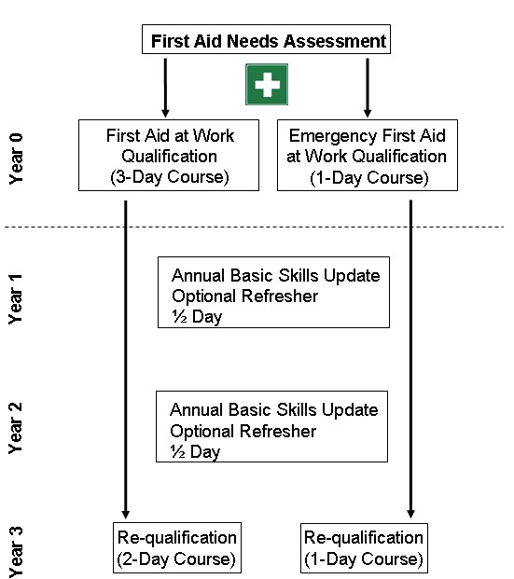
Records
Copies of training certificates must be maintained by local management.

Refresher training
Training should be planned ahead to ensure the provision of qualified first-aider remains in accordance with the first-aid needs assessment conclusions.
** Note some services may have requirements that require their training to be carried out at more regular refresher intervals such as those providing Lifeguard duties in a swimming pool.

Appendix 5 – Management check sheet and flow chart

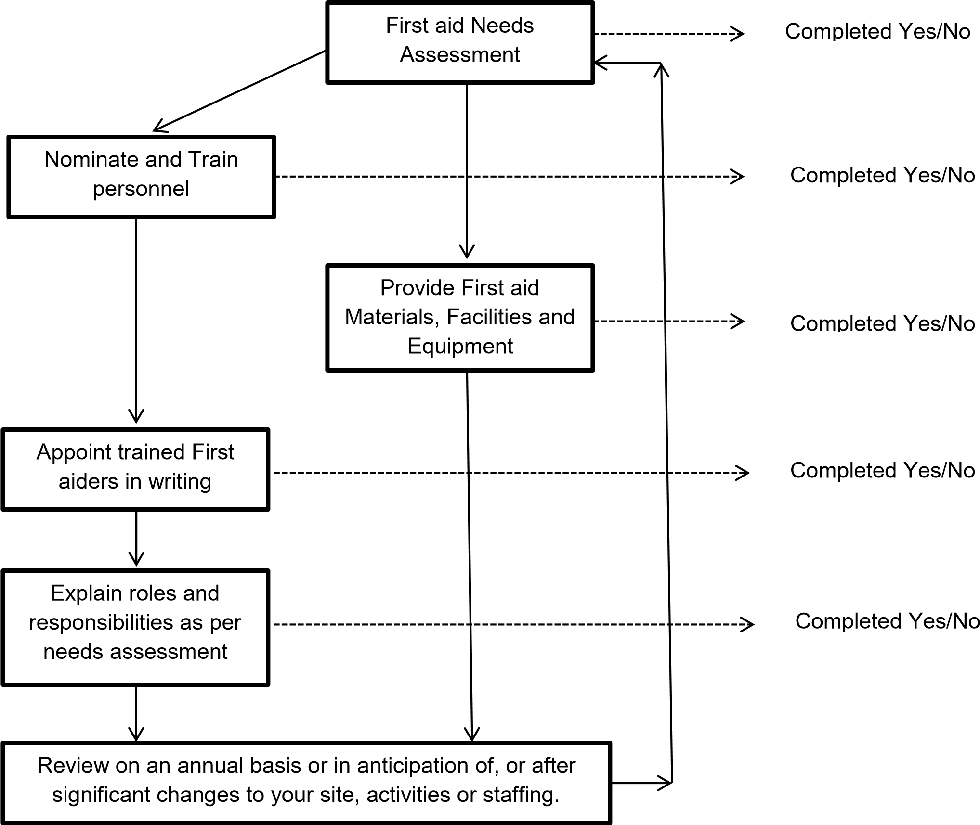

Appendix 6 – First-aid signs example
